Student ID: s8117545

Student Name: Ankit Shrestha

Lab Activity: Lab 2.1

Problem:

Write a program that inputs a filename from the user and prints to the terminal a report of the wages paid to the employees for the given period. The report should be in tabular format with the appropriate header. Each line should contain an employee’s name, the hours worked, and the wages paid for that period.

Code:

Test Run 1:

Test Run 2:

Test Run 3:

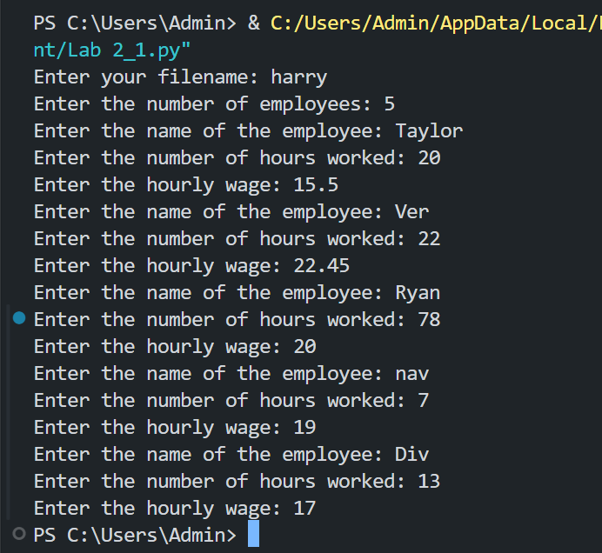

My Peer

Student Name: Ryan Bower  
Student ID: s8128380

Feedback Received: Code is effective and runs correctly. shown to work with multiple different inputs giving correct outputs as well as being easily readable. however could use more annotations to show understanding of the code and task given.